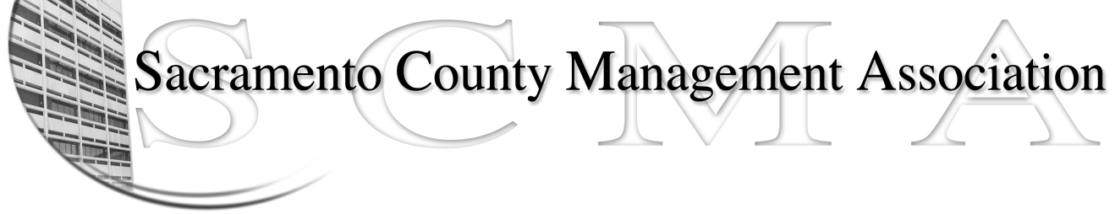

Mike Guiver, President Craig Rader, Board Member
RoseMary Vaske, Vice President Brad Buyse, Board Member
Nancy Gust, Secretary Robert Nelson Board Member
Forrest Williams, Treasurer Bruce Coker, Board Member
Sue Elliott, Board Member
April 12, 2010

Dear 050 County Counsel Managers:

On April 29, 2010 an election by secret ballot will be held to determine whether the employees of 050, who have not been “carved out” by Labor Relations, desire to be represented by the Sacramento County Management Association (SCMA) and become a recognized employee organization (REO). As part of the election process, County Counsel managers will have the option to be represented by SCMA within their own unit.

The State of California Mediation and Conciliation Services is the third party organization that will be conducting the election. You should have received an email from the County that contained your polling place location, when your polling place will be open, and other information relating to the election process.

Additionally, there will be notifications posted at all work sites explaining the process and listing polling places. Please note that polling places will be open for a limited amount of time so it is important that you get to your specified polling place during the hours of operation. By law, your employer must allow adequate time off for you to vote.

If you are unable to vote at your designated polling place and wish to request an absentee ballot, please call 510-873-6465 on April 15th or 16th between the hours of 8:00 a.m. and 5:00 p.m. These are the ONLY days you can request an absentee ballot. To cast your vote via absentee ballot, your ballot must be received by mail no later than the close of business on Tuesday April 27, 2010. Absentee ballots received after that date will not be counted.

Remember, all votes will be kept confidential. Results from the election will be posted on the SCMA website (scmamgt.org) as soon as they are available.

We hope that you continue to allow SCMA to represent your interests as a manager in Sacramento County. We believe you will have greater autonomy as a separate unit under SCMA as we strive to get the best benefit package possible for all County managers.

Thank you.

SCMA Board of Directors

SCMA’s semi-annual luncheon will be held at the Sacramento Hilton on June 24th. Registration begins at 11:15. Go to scmamgt.org now to make your reservation. SCMA members – free, non-members – $35.00.

